The Lymphatic System
Name
Institution of Affiliation
Professor
Date

The Lymphatic System
The lymphatic system is one of the human body’s systems that are paramount yet it may be overlooked. It is a crucial system in the body because were it not for it the human biology will not be able to coordinate waste excretion and also in fighting foreign materials. It is a system that is of interest to me and that is why I have chosen to describe it. The lymphatic system is a system that is made up of several organs interconnected throughout the body to help in proper functioning (Swartz, 2001). It has principle organs which include the thymus, the spleen, lymph nodes, tonsils, and adenoids. All these organs are connected by lymphatic vessels that are ultimately connected to the circulatory system in the body. The system transports lymph which is a liquid that contains waste, debris and various white blood cells that fight against the various infective agents invading the body.
There are hundreds of lymph nodes in the whole body located in different organs to help in tapping the lymph from those organs. According to Randolph, Ivanov, Zinselmeyer, and Scallan (2017), the lymph nodes have lymphatic drainage vessels whose function is to ensure that the formed lymph is well transported from the lymph nodes. The lymph nodes' function is to filter the waste materials from the organs that they are located in the body. For example, the hilar lymph nodes are located on the lungs so that they filter out all the formed lymph which is a mixture of dead tissues and used white blood cells that have already performed their function of fighting infective agents. In a case of bacterial pneumonia, the white cells are transported to the lungs where they fight the invading microorganisms, for example, the phagocytes engulf and kill them (Tortora & Derrickson, 2017). These wastes then need to be removed from the lung tissues and hence the work of the lymph nodes.
The thymus is also part of the lymphatic system and its work is to generate disease-fighting white blood cells called lymphocytes. They are then transported to the various tissues and organs through the lymphatic vessels where they are needed to fight against foreign materials and microorganisms (Scanlon & Sanders, 2018). They are actually specialized cells called T lymphocytes and they are categorized as the activated immune system.
The spleen is the largest lymphatic system organ in the body. It has several functions. One of the functions is to act as a filter of the blood content. The blood passes through the millions of sinusoids in the spleen where any waste materials and all the blood cells that need to be removed from the circulation are filtered from the blood (Tortora & Derrickson, 2017). This includes the used white blood cells after fighting microorganisms. It, therefore, helps in fighting against infections in the body. In case the spleen detects invasion by microorganisms like bacteria, it stimulates production of lymphocytes whose sole function is to fight against the bacteria. All the filtered waste product in the spleen is then transported via lymphatic drainage system away from the spleen towards the venous system through lymphatic ducts. Adenoids and tonsils are located in the along the pharynx and the two organs help in engulfing microorganisms like bacteria, fungi, and virus that enters through the mouth and the nose. They release white blood cells which help in fighting the invasion and then dead cells and debris are filtered from the two organs to the rest lymphatic vessels and ultimately to the thoracic duct then to the venous system via superior vena cava (Randolph, Ivanov, Zinselmeyer &Scallan, 2017). The superior vena cava connects to the heart and the waste is excreted via the kidneys as urine. The lymphatic system is, therefore, an important system in the body in fighting germs and in the transportation of waste materials from the body organs to avoid toxic levels.

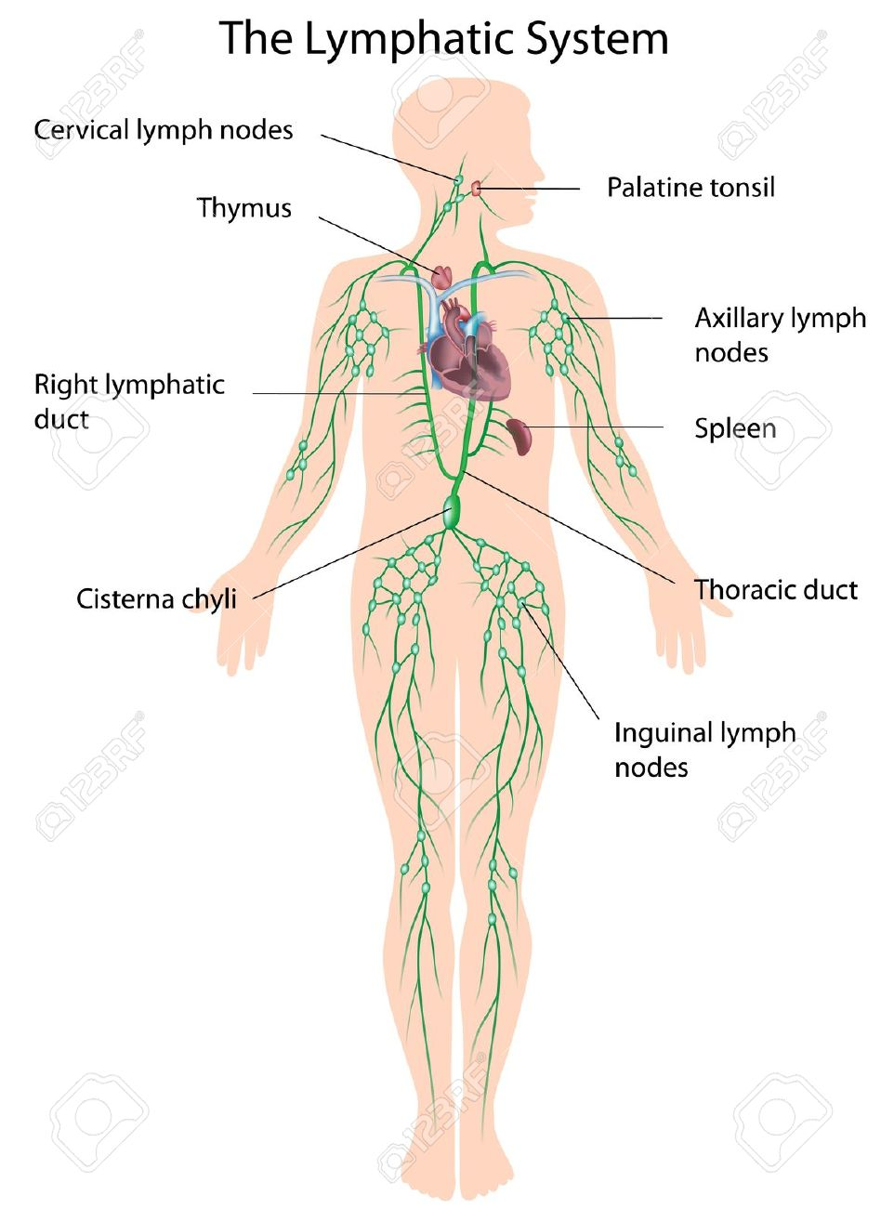

References
Randolph, G. J., Ivanov, S., Zinselmeyer, B. H., & Scallan, J. P. (2017). The lymphatic system: integral roles in immunity. Annual review of immunology, 35, 31-52.
Scanlon, V. C., & Sanders, T. (2018). Essentials of anatomy and physiology. FA Davis.
Swartz, M. A. (2001). The physiology of the lymphatic system. Advanced drug delivery reviews, 50(1-2), 3-20.
Tortora, G. J., & Derrickson, B. (2017). Principles of anatomy & physiology. John Wiley & Sons, Incorporated.

